|  |  |
| --- | --- |
| Stella Nova Logo | LOGO4 |
| Best Buy Canada Mobile | |
| |  | | --- | | **Salesperson Capture Feature Document** |   **Document Version: 1.2**  **Design Date: April 4, 2012** | |
| **Prepared By: Amy Lackas** | |
|  | |

**Table of Contents**

*1.* *Feature Overview* 3

1.1 Feature Description 3

1.2 Assumptions 3

1.3 Parameters and System Settings 3

1.4 Interfaces 3

*2.* *USE CASE: Salesperson Capture* 4

2.1 Feature Flow 4

2.2 Precondition 4

2.3 Main Flow 4

2.4 Alternate Flows 5

2.5 Post Condition 5

2.6 Special Requirements 5

*3.* *Supplemental Specifications* 5

3.1 Electronic Journal 5

3.2 POSLog 5

3.3 Printed Receipts 5

3.4 Suspend Feature 5

*4.* *Screen Layouts* 6

4.1 Salesperson Capture 6

4.2 Salesperson Search 7

4.3 Salesperson Search Results 9

*5.* *Business Sign Off* 10

*6.* *Revision History* 10

*7.* *Appendix A: Glossary* 10

# *Feature Overview*

## Feature Description

Retailers use the process of linking a salesperson to items in a transaction and/or to the transaction for a variety of reasons ranging from tracking overall sales to aiding in the calculation of commission payments.

## Assumptions

1. For Related Items (Parent / child items), the child item must be assigned a salesperson separately.
2. A transaction can contain multiple transaction level salespersons (in addition to the sign on ID) and each item within the transaction can contain multiple salespersons.
3. An employee selected from search results is considered to be a valid employee.
4. All text displayed by the system is configurable by brand to support multi-language.  Text is defined from an external source or defined within the system.
5. All Manager Overrides are bypassed for Phase 1.

## Parameters and System Settings

|  |  |  |
| --- | --- | --- |
| **Parameter Mnemonic** | **Description** | **Valid Values** |
| Salesperson Lookup Timeout | Determines the timeout threshold in seconds that is used when the system attempts to contact the server before returning an offline response. | 1-15 |
| Maximum Number of Salesperson Search Result Rows Per Page | Determines maximum number of salesperson search result rows displayed per page. | * 0-999 |
| Maximum Number of Salesperson Search Result Pages | Determines maximum number of salesperson search result pages displayed. | * 0-999 |

## Interfaces

|  |  |
| --- | --- |
| **Interface** | **Description** |
| None |  |

# *USE CASE: Salesperson Capture*

## Feature Flow



## Precondition

* The operator selects to link a salesperson to an item or transaction.

## Main Flow

1. The system prompts the operator to enter a salesperson ID or search for a salesperson ID.
2. If the operator selects to search for a salesperson ID, the Salesperson Search Alternate Flow is executed.
3. The operator enters a salesperson ID and accepts the entry.
4. The system determines if the entered salesperson ID is valid.
5. If the entered salesperson ID is invalid, the system displays a message, the operator acknowledges the message and the system restarts the Main Flow.
6. The system links the salesperson to the item.
7. The system logs the captured salesperson at level requested and the use case ends

## Alternate Flows

### Salesperson Search

1. The system prompts the operator to enter search criteria.
2. The operator enters the search criteria and accepts the entry.
3. If the operator accepts the entry without completing all required fields, the system displays a message, the operator acknowledges the message and the system restarts the alternate flow.
4. The system searches for the salesperson information.
5. If no results are returned or no results are found because the system is offline or the search times out, the system displays a message; the operator acknowledges the message and the Main Flow is restarted.
6. If the search returns results, the system displays the search results and prompts the operator to select a salesperson or select an option.
7. If the operator selects to search for salesperson the alternate flow is restarted.
8. The operator selects a salesperson and selects to continue.
9. The system returns to the calling use case where the system links the captured salesperson and the alternate flow ends.

## Post Condition

* Salesperson has been captured and linked at the level requested.

## Special Requirements

1. If a transaction level salesperson is added after an item level salesperson is added, the system removes the item level salesperson.
2. If a transaction is suspended, the system logs the salesperson at the level it was captured.
3. In validating the entered salesperson ID, the system checks that the ID exists and that the employee has not been terminated.
4. The system validates that the entered salesperson ID is an employee with the company (looking at the hire and termination date).
5. If an employee is not a current employee for the company (looking at the hire and termination date), the salesperson is not displayed on the results screen.
6. When store number is a search criteria field, the system defaults/prefills with the current store number.

### Special Offline Requirements

TBD

### Data Input/Output

|  |  |  |
| --- | --- | --- |
| **Data Element** | **Description** | **Destination** |
| Salesperson ID | ID for the captured salesperson. The value is logged at the level it was captured. This ID is the same as the employee ID and the ID used for sign on. | * Electronic Journal * POSLog |
| BBX ID | The alphanumeric value associated with the captured salesperson ID. | * Receipt |

# *Supplemental Specifications*

## Electronic Journal

Electronic journal mockups for this feature are documented in the BBYC Phase 1 Electronic Journal document.

## POSLog

POSLog mockups for this feature are documented in the BBYC Phase 1 POSLog document.

## Printed Receipts

Printed receipt mockups, where applicable, are documented in the BBYC Phase 1 Receipt Generation document.

## Suspend Feature

The Suspend Use Case is updated to reflect that the data captured prior to suspending a transaction is available when the transaction is resumed.

# *Screen Layouts*

## Salesperson Capture

This screen is displayed when the operator selects to capture a salesperson at the item or transaction level. The operator has the option to enter the salesperson ID or search for a salesperson.

### Mockup

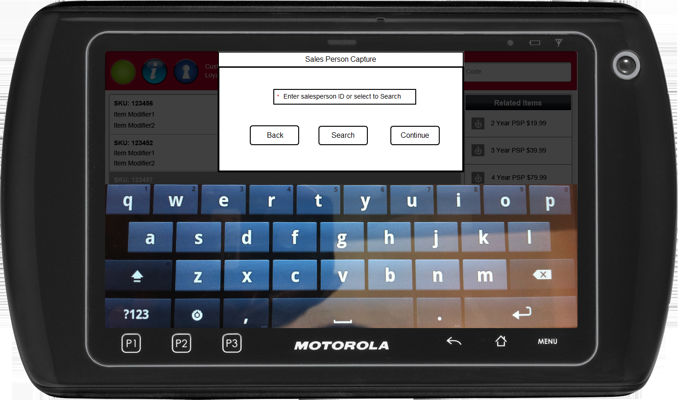

Figure 1: Salesperson Capture

### Instruction Text

|  |
| --- |
| **Instructions** |
| None |

### Navigation/Menu Key

|  |  |  |  |
| --- | --- | --- | --- |
| **Label** | **State** | **Next Screen** | **Notes** |
| Back | Enabled | Previous screen | None |
| Search | Enabled | Salesperson Search | None |
| Continue | Enabled | * Salesperson ID Not Found: Salesperson Not Found * Salesperson ID Found: Item Entry | None |

### Data/Input Field

|  |  |  |  |  |  |  |
| --- | --- | --- | --- | --- | --- | --- |
| **Label** | **Editable** | **Req’d?** | **Data Type** | **Min**  **Length** | **Max**  **Length** | **Notes** |
| Enter salesperson ID or select Search | Yes | Yes | Alphanumeric | 1 | No Limit | Field supports manual entry |

### Reason Code

|  |  |  |
| --- | --- | --- |
| **Reason Code** | **Valid Values** | **Default Value** |
| None |  |  |

### Salesperson Not Found

|  |  |
| --- | --- |
| **Description** | This message is displayed when the system is offline or the search does not return any results based on the search criteria entered. When the message is acknowledged, the system returns the operator to the previous screen. |
| **Message** | No salesperson found. |
| **Key prompt** | Ok |
| **Notes** | Configurable message |

## Salesperson Search

This screen is displayed when the operator selects to search for a salesperson and prompts the operator to enter the first and last name. For salesperson searching purposes, the system supports the use of wildcards. For example, the search for salesperson ID can be 12* which would return all valid salespesron IDs that begin with 12. The only wildcard supported by the system is the * symbol.

### Mockup

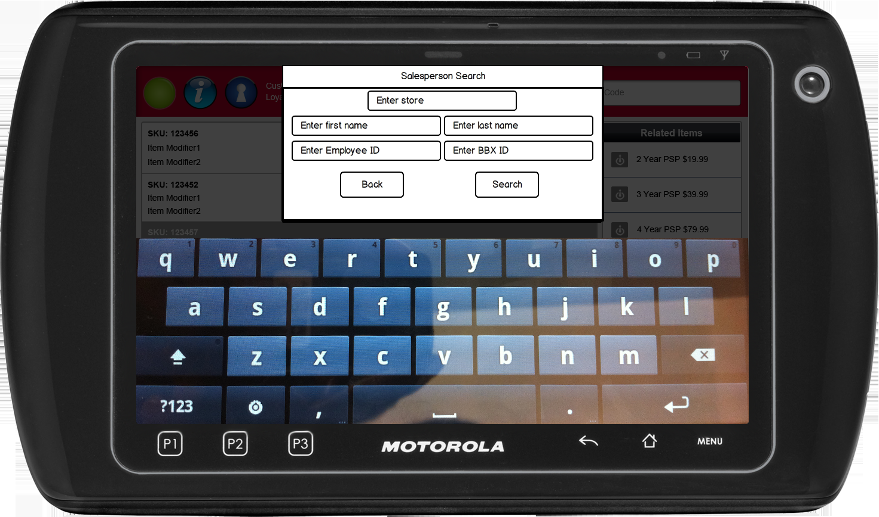

Figure 2: Salesperson Search

### Instruction Text

|  |
| --- |
| **Instructions** |
| None |

### Navigation/Menu Key

|  |  |  |  |
| --- | --- | --- | --- |
| **Label** | **State** | **Next Screen** | **Notes** |
| Back | Enabled | Previous screen | None |
| Search | Enabled | * If any of the required fields are left blank: Invalid Data Notice * If the sales associate number is not found or offline response: Sale Associate Not Found * If the sales associate is found: Salesperson Results | None |

### Data/Input Field

|  |  |  |  |  |  |  |
| --- | --- | --- | --- | --- | --- | --- |
| **Label** | **Editable** | **Req’d?** | **Data Type** | **Min**  **Length** | **Max**  **Length** | **Notes** |
| Enter store | Yes | See Notes | Numeric | 1 | 4 | At least one of the fields are required to be entered, but not all of them. |
| Enter first name | Yes | See Notes | Alphanumeric | 1 | 26 | At least one of the fields are required to be entered, but not all of them. |
| Enter last name | Yes | See Notes | Alphanumeric | 1 | 26 | At least one of the fields are required to be entered, but not all of them. |
| Enter Employee ID | Yes | See Notes | Alphanumeric | 1 | 8 | At least one of the fields are required to be entered, but not all of them. |
| Enter BBX ID | Yes | See Notes | Alphanumeric | 1 | 8 | At least one of the fields are required to be entered, but not all of them. |

### Reason Code

|  |  |  |
| --- | --- | --- |
| **Reason Code** | **Valid Values** | **Default Value** |
| None |  |  |

### Salesperson Not Found

|  |  |
| --- | --- |
| **Description** | This message is displayed when the system is offline or the search does not return any results based on the search criteria entered. When the message is acknowledged, the system returns the operator to the previous screen. |
| **Message** | No salesperson found. |
| **Key prompt** | Ok |
| **Notes** | Configurable message |

## Salesperson Search Results

This screen is displayed when the operator searches for a salesperson and the search returns one or more results. The screen prompts the operator to select a salesperson.

### Mockup

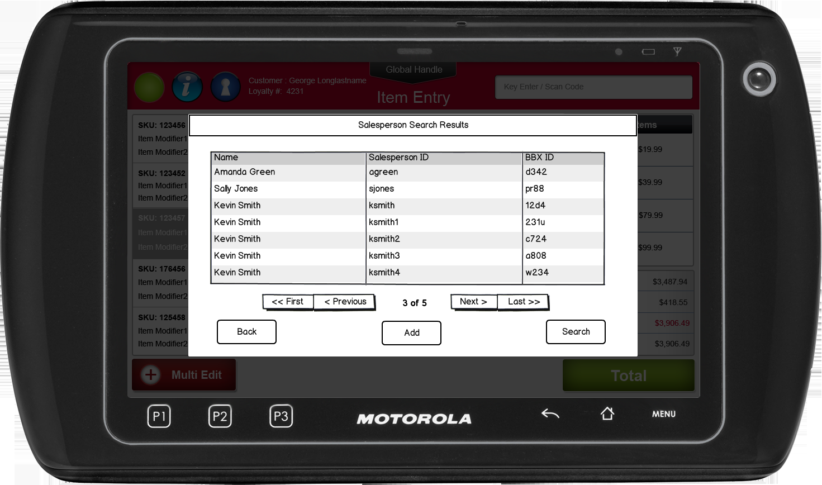

Figure 3: Salesperson Search Results

### Instruction Text

|  |
| --- |
| **Instructions** |
| None |

### Navigation/Menu Key

|  |  |  |  |
| --- | --- | --- | --- |
| **Label** | **State** | **Next Screen** | **Notes** |
| Back | Enabled | Sale | None |
| Search | Enabled | Salesperson Search | None |
| Add | See Notes | Sale use case | * Entry is selected to enable. * System links the selected salesperson to the appropriate level (item or transaction) * Results are displayed in the following order: Name, Employee ID and BBX ID. * If needed, a scrollbar appears if needed to view the results. |

### Data/Input Field

|  |  |  |  |  |  |  |
| --- | --- | --- | --- | --- | --- | --- |
| **Label** | **Editable** | **Req’d?** | **Data Type** | **Min**  **Length** | **Max**  **Length** | **Notes** |
| List | No | Yes | N/A | N/A | N/A | Row is selectable by tapping the entry. |

### Reason Code

|  |  |  |
| --- | --- | --- |
| **Reason Code** | **Valid Values** | **Default Value** |
| None |  |  |

# *Business Sign Off*

|  |  |  |
| --- | --- | --- |
| **Name** | **Organization** | **Date** |
| <Name of signer> | <Organization of signer if applicable> | <date of sign off> |

# *Revision History*

|  |  |  |  |
| --- | --- | --- | --- |
| **Reviser** | **Revision** | **Date** | **Version** |
| Amy Lackas | Finalized version | 05/01/2012 | 1.1 |
| Amy Lackas | Clarified the validation done on the salesperson to look at the hire and termination date | 05/17/2012 | 1.2 |
| Amy Byers | Added clarification that store search criteria field defaults to current store  Added requirements matrix. | 9/01/2014 | 1.3 |

# *Appendix : Source Documentation*

* Requirement Specification - XPOS

## Functional Requirements

| **ID** | **Category** | **Sub-Category** | **Description** | **Section(s)** |
| --- | --- | --- | --- | --- |
| 2.31 | Functions | Salesperson Capture | When performing a salesperson search (Transaction or Item level), the store number will be defaulted to the calling store. | * 2.6 Special Requirements |

# *Appendix : Glossary*

|  |  |
| --- | --- |
| **Term** | **Definition** |
| BBX ID | This is an alphanumeric ID that is associated with an employee ID. The value is only used for displaying the receipt instead of the employee ID for certain situations. |
| Salesperson ID | This is the same as the employee ID. |